Intermediary Project Report for Vizualizer Project

Summary of Original Proposal
The project covers the development of a code visualization tool to allow for better understanding of the high-level relationships in software projects.

High-Level Goals include:
- Support scanning medium-large sized Java software projects, up to 500k SLOC
- Provide a visual representation of the software through a UI that allows views of the following:
  - Package diagram
  - Class association diagram
  - Unreferenced classes diagram

The project specifically excludes creating a custom visualization layer. Instead, a JS recompilation (Emscripten) of graphviz will be used to provide the visualization layer. This will create constraints on the size of the projects that can be displayed. However, writing a custom graphing library was deemed unreasonable for the time frame.

Key Accomplishments to Date (4/14/2016)
Example screen shots are provided at the end of this document.

- A basic web-browser based GUI has been created to allow a user to interact with the tool.
- The open source “Java Parser” (http://javaparser.github.io/javaparser/) has been integrated with support for Java 1.8.
- The visitor pattern of Java Parser has been used to create a custom intermediate model of the Java code.
- Translation of the intermediate model to both “Neato” and “Dot” formats implemented.

Remaining Tasks and Schedule

Our progress to date is ahead of schedule. Thus, we’ve added a few stretch goals, listed below. These will be accomplished, time-permitting. In general, the schedule provided by the assignment instructions will continue to be followed.
- Provide a depth-based selection criteria, enabling a user to select items to be graphed and then specify the number of edges beyond the selection that should be graphed. (Expected completion date : 4/15)
- Provide color-coding of nodes included via depth-based selection. (Expected completion date: 4/16)
- Provide text search allowing a user to select the nodes to graph by providing a search query and “hits” value (n). The top-n results will be selected by the system for graphing. (Tentative completion date: 4/30)
- Combine the text search feature with the depth-based selection criteria. (Tentative completion date: 4/30)

Screenshots

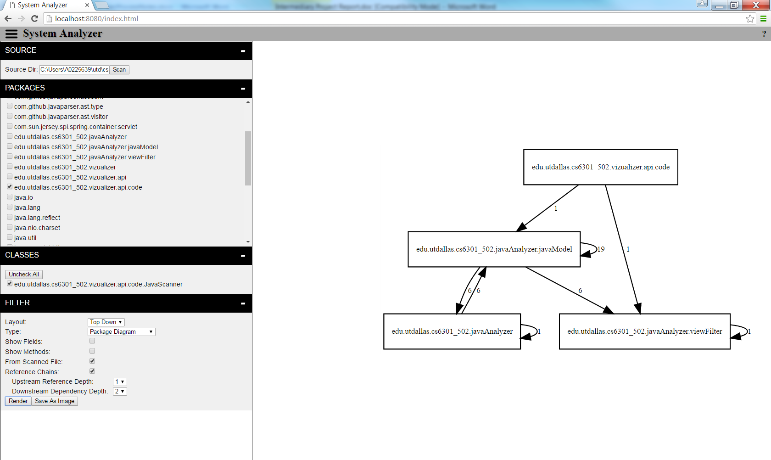
Figure 1: Web-based GUI, showing package diagram with depth based selection.

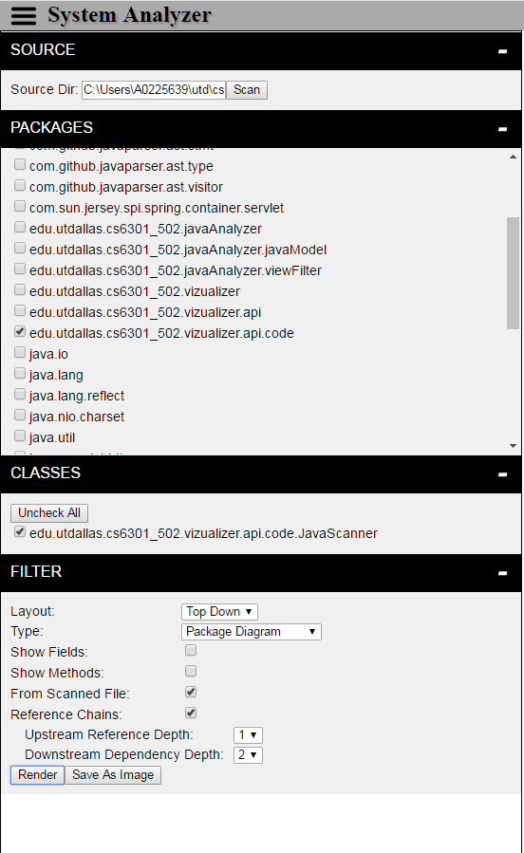
Figure 2: Close up of GUI for user input.

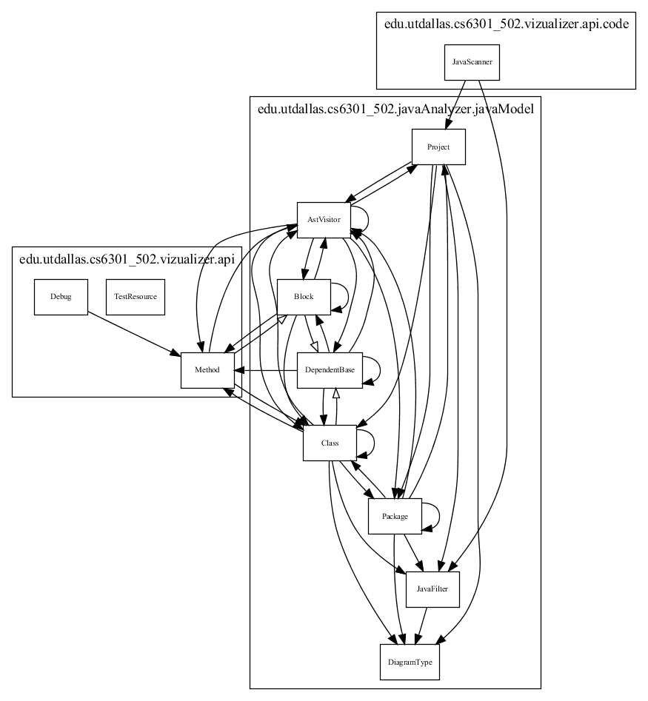
Figure 3: Example Class Association Diagram from tool

